Module 1: Introduction to Cybersecurity

What is Cybersecurity?
Cybersecurity is the practice of protecting computer networks, devices, and information from damage, loss or unauthorized access. It is important to note that cybersecurity protects digital information from cyberthreats. The protection of information means the preservation of confidentiality, integrity, and availability of information in the cyberspace. Cybersecurity professionals act to protect servers, endpoints, databases, and networks by finding security gaps and misconfigurations that create vulnerabilities. Cybersecurity can be divided into five categories: critical infrastructure security, application security, network security, cloud security, and the Internet of Things (loT) security. Note that other organizations may categorize the types of cybersecurity differently or label them differently. In addition to these five categories there are the people and processes that use technology to defend computer systems, networks, and the information therein.
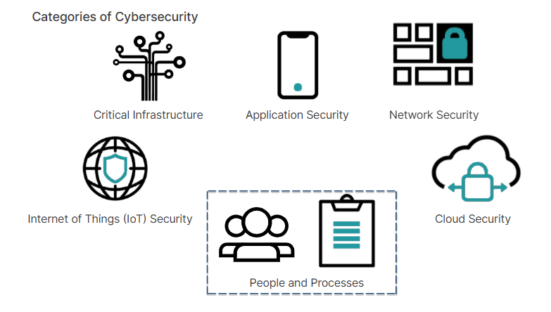
These different categories reflect the extent that computer technologies have transformed the world. From online management of gas pipelines or electrical grids to applications that allow you to buy and sell goods online to collaborating with work colleagues irrespective of geography to renting data storage in the cloud to tracking printer toner and maintenance, all of these technologies have transformed how people live and how they do business. The digital transformation has realized enormous efficiencies, expanded unheard of conveniences, supplied omnipresent access to information, and exponentially increased productivity, which has grown wealth and improved the quality of life. For example, people living in remote areas of the world can access medical experts using computer technologies. Personal medical information can be collected locally and transferred to medical experts to assist in diagnosis and remedies. Without securing computer networks and the links that connect them, all of these advances are at risk.

Information security,

also known as InfoSec, is the practice of protecting information. InfoSec includes the tools and processes used for preventing, detecting, and remediating attacks and threats to sensitive information, both digital and physical. InfoSec also includes documenting the processes, threats, and systems that affect the security of information. The nature of the information is inclusive and broad. It includes information stored electronically on a computer, or information laying on someone's desk, or stored in a file cabinet. Information that might require protection could also include everything from mission- critical data, to HR policies to legal contracts. IT security scrutinizes all information within an organization in order to categorize and prioritize its sensitivity. Some information is labelled as unprotected, meaning that no controls are necessary, while some information is labelled as protected, meaning that some level of protection and control is required. Depending on the protected information's criticality, it could be labelled confidential, secret, or top secret. Each successive protected level requires more rigorous control and safeguards.
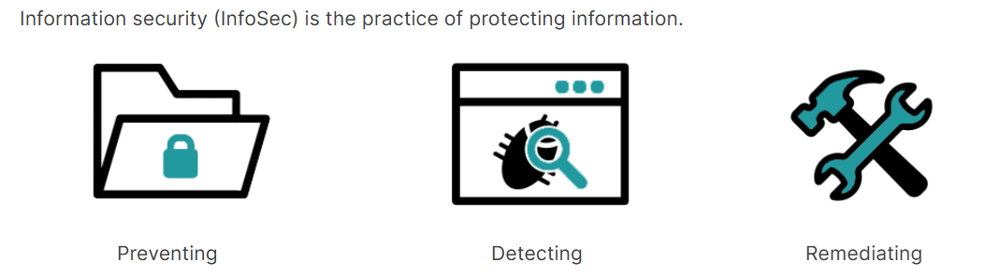
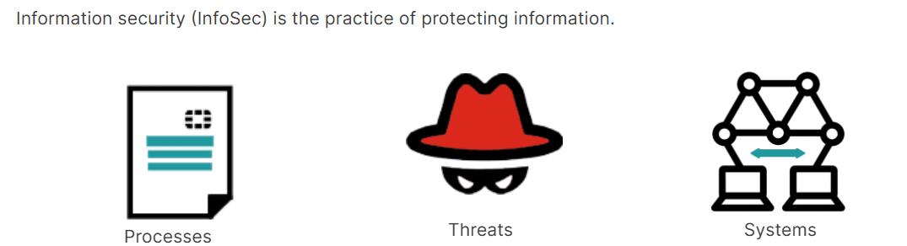
Information systems security is a part of InfoSec. It is defined as the protection of information systems against unauthorized access, modification, destruction, or the denial of access to authorized users. Information systems include the devices, computer networks, and physical locations that store or transmit sensitive information. The form of the information can be digital or physical. Given what you now know about the terms discussed in this lesson, you can conclude that information systems security is a subset of InfoSec and cybersecurity is a subset of information systems security.
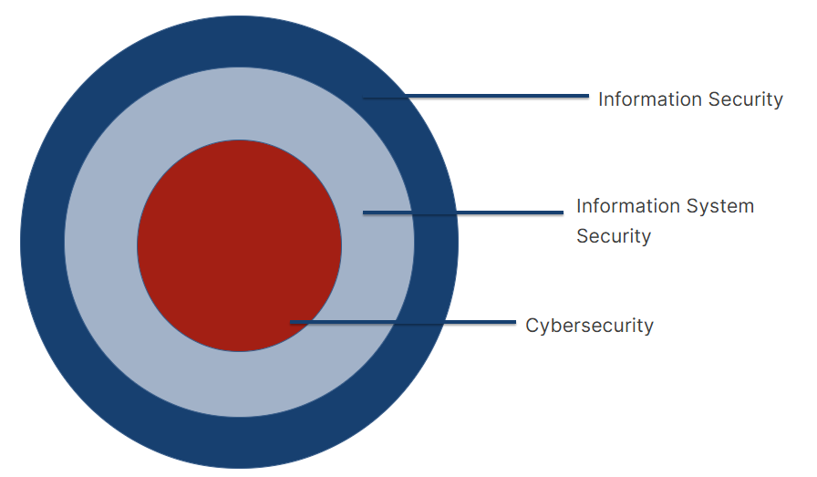

Given the importance of protecting this cyber infrastructure, which is vital to the continued prosperity and quality of life to much of the world, certain precautions can be taken. It starts with people and education. Numerous studies have identified human error as the leading cause of network and computer breaches. This situation can be addressed by educating people at work and at home to think before clicking and to help them identify phishing attacks and other common attack methods by bad actors. Another first line of defense, both at work and at home is to prepare for disaster and plan for recovery. If you do regular backups of your data and these are kept safely offline, then should your data be deleted or corrupted by malware, or encrypted by ransomware, you can restore your data with the least amount of data loss and interruption.

Principles of InfoSec
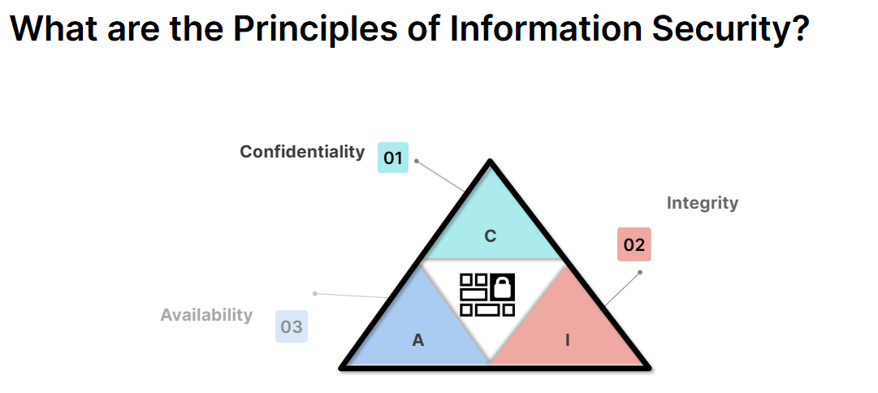
There is a triad of principles that constitutes the objectives of information security. These principles are confidentiality, integrity, and availability which form the letters C-I-A. Private information must remain confidential. You need to know who is trying to access the information and whether or not they are authorized to access it. You must also have assurance that the information is authentic, in other words has integrity. The information must be protected from an unauthorized change, and if it is altered then you must be alerted to this fact. Last, authorized parties must have access to the information. Technologies, policies, and processes must be in place to ensure reliable availability. Together, these three principles constitute the CIA triad. Conversely, Infosec works to prevent the disclosure and alteration of information. In addition, it strives to ensure that authorized parties are not denied information. These characteristics, known as the DAD triad, are the opposite of the CIA triad. Disclosure exposes confidential data to unauthorized parties. The alteration of data, or the inability to test for alteration, makes the data untrustworthy. Denial of information prevents legitimate and authorized agents from accessing data. An effective security solution, such as a network firewall, will help neutralize the DAD triad.
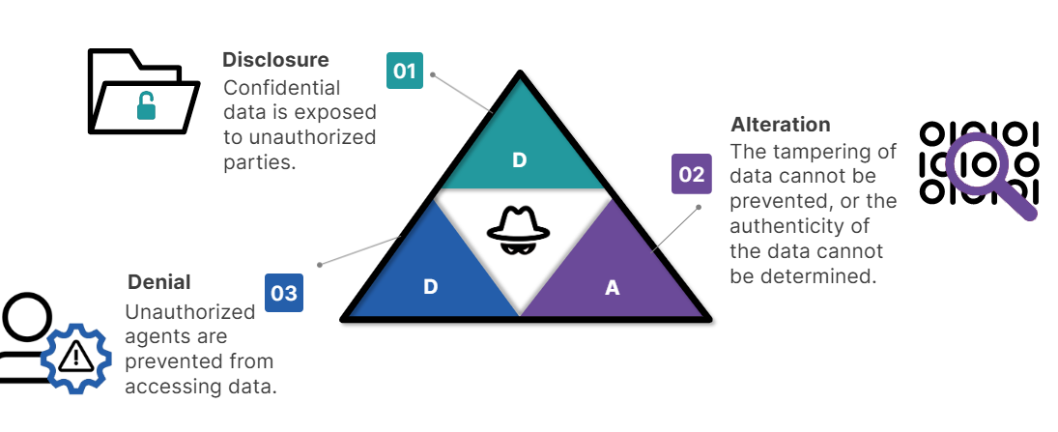

AAA
The three security terms that you should be conversant with are authentication, authorization, and accounting (AAA). Together, AAA constitutes a security framework that controls resources, enforces policies, and audits usage. The security framework plays a major role in network management and cybersecurity by screening users and keeping track of their activities while they are connected. Authentication is the process of identifying and verifying a person or thing. As an identity and access management (IAM) tool, a AAA server compares a user's credentials with its database of stored credentials by checking if the username, password, and other authentication tools align with that specific user. Authorization is the process of controlling access to resources. During authorization, a user can be granted privileges to access certain areas of a network or system. The areas and sets of permissions granted a user are stored in a database along with the user's identity. The user's privileges can be changed by an administrator. Last, accounting in information technology is the record- keeping and tracing of agent activities on computer devices and networks. Accounting tracks information such as the length of time a user was logged in, the data they sent or received, their internet protocol (IP) address, the uniform resource identifier (URI) they used, and the different services they accessed. Accounting may be used to analyze user trends, audit user activity, and provide more accurate billing.
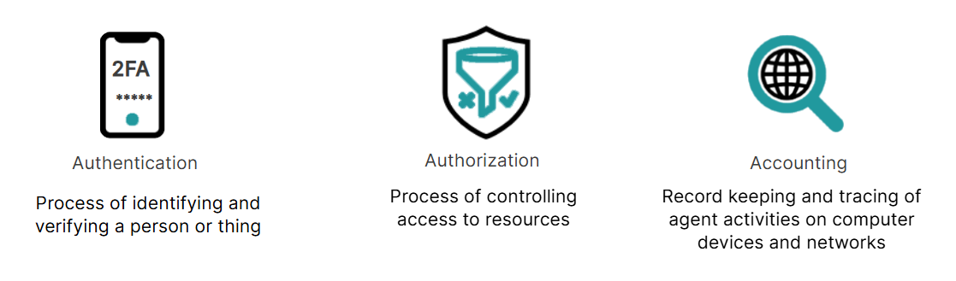

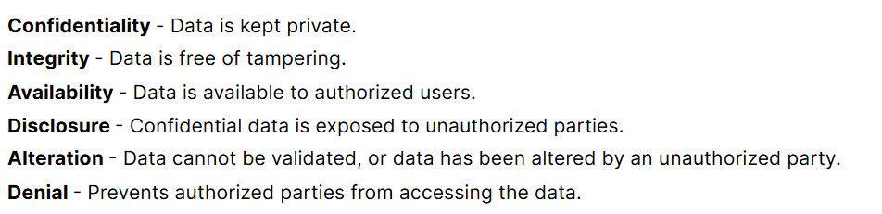

The Threat Landscape

What is threat to landscape?
What is a threat landscape? A threat landscape is the collection of threats in a given context or domain and includes information about the perpetrators of the threats: the bad actors. In the context of cybersecurity, the threat landscape includes all known and possible threats to computer networks. The introduction of new technologies and methods ensures a dynamic landscape where evolving new threats arise on an ongoing basis. Understanding the nature of the threats posed to your network arms you with the knowledge to counter and defeat attacks against computer systems. The lessons in this Threat Landscape module provide an essential understanding of the following fundamentals necessary to achieve your goals. You will be able to: Identify the different types of bad actors and hackers by their motivations and tactics. Different types of bad actors are more likely to attack certain verticals or types of businesses. For example, hospitals are big targets of cyber criminals who want to ransom valuable medical information to enrich themselves. A nation's department of defense is more likely to be attacked by other nation state threat actors, who are more interested in stealing state secrets than extracting money from their victims. Therefore, by knowing your enemy you are better equipped to counter their attacks.
You will be able to:
Describe attack vectors, cybersecurity threats, and the categories that cyberthreats fit into. Understanding the classification of threats gives you insight into how attacks can be carried out. Again, this can help you to identify weaknesses in your environment and take precautions to reduce the attack surface. You will be able to: Define threat intelligence and explain how it is processed. For information to be threat intelligence, it must be relevant, actionable, and contextual. If it is not all of these things, then it is not threat intelligence. However, this is also very situational, so what is intelligence for one organization may not be intelligence for another. You will be able to: Describe different attack frameworks, such as the Cyber Kill Chain and MITRE ATT&CK. Attack frameworks give you a glimpse into the anatomy of a cyberattack. Understanding the chain of actions in an attack enables you to anticipate your enemy's actions and counter them. Also, frameworks like MITRE ATT&CK are rich in information and threat intelligence that you need to be an effective IT security professional. Proceed to the first lesson to get started.

Threat Actors
What is a bad actor? Bad actors, also known as threat actors, are persons who try to steal, sabotage, or stop you from using computer systems or accessing information that you are authorized to use and that is stored on or in transit between computing devices. There can be a myriad of motivations for their criminal behavior, and these different motivations not only influence their attack methods but provide insight into their character and beliefs. Bad actors can be grouped into types based on their character, motivations, and the common attack methods that they use. It's important to note that bad actors are NOT a homogeneous group. While there are various types of bad actors who have different motivations that help explain their activities, you should not view a bad actor as a mysterious hooded character who works in a dark basement, in another country, or in another city. A bad actor could be anyone, located anywhere. It could be someone in a local coffee shop who is setting up a fake Wi-Fi access point to steal data, a disgruntled employee who is leveraging their employee status to gain deeper access to corporate data, someone in another country whose full-time job is to scam people from a call center, or it could be a teenager in your neighborhood who is curious about the freely available programs on the internet that makes distributing malware and ransomware as easy as a few clicks of the mouse. The types of bad actors are explorer, hacktivist, cyberterrorist, cybercriminal, and cyberwarrior.
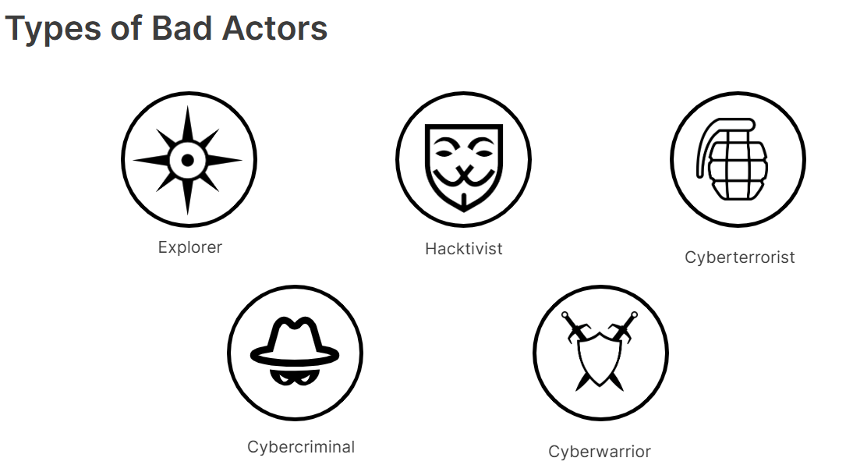
The explorer is perhaps the least nefarious of all the bad actor types. Notoriety is the biggest motivator within this group. The explorer is curious about the kinds of weaknesses that exist on computer networks and strives to find and exploit them. They do not intend to inflict serious damage, but they might change a page on a website to embarrass someone or do something to advertise to the world how clever they are. One method used by explorers and other bad actor types is called phishing. Essentially, they trick people into giving up personal information. An example of phishing is an email from a seemingly legitimate source to a broad group of people. The ingredients of a successful phishing attack are, one, to gain the trust of the recipient or at least to appear innocuous, and two, to manufacture an emergency to force the recipient to act. There are variants of phishing that can be deployed as well. Spear phishing also uses email, but the email is directed at a specific person or group. The explorer also might choose to call or text you, better known as smishing and vishing. While not using email, the same ingredients are required for the scheme to be successful. Phishing and its variants, however, are not exclusive to the explorer, and other bad actor types might use them for their own purposes. Click the icons and buttons for more information.
Phishing Example:
A phishing email might state that some business demands the recipient's immediate attention and a link to the organization's site is provided for their convenience. The link, however, does not direct their browser to the legitimate site but rather takes them to a look-a-like rogue site. The rogue site provides the login page and the victim dutifully types their username and password. When the victim clicks submit the rogue site returns a message that their password was incorrect. A link is provided to the legitimate login page, the victim tries again, and this time logs in successfully. Because people often type their passwords quickly and sometimes make mistakes, the victim may not be alerted to the fact that something fishy has transpired. But meanwhile, the bad actor has the victim's username an password and can now log in as them.

Unlike the self-interested explorer, hacktivists are fervent believers in an external cause. They are motivated by ideology or are animated by an emotive force. The hacktivists' idealism drives them to act collectively in common cause against an enemy. While hacktivists may collectively crusade against a specific corporation, or go after political or social organizations that they feel did something bad, their extremism demands anonymity and online groups, by nature, are fragmented. A common strategy of hacktivists is to build a botnet in secret. To make a botnet, the hacktivist sets up a command-and-control (C&C) server that is accessible on the internet. This is a central coordination point for all the botnet nodes. Next, they craft malware that, once installed on some unsuspecting computers, waits patiently for instructions from the C&C server. The C&C server instructs thousands of botnet nodes to send messages to the targeted server, which becomes overwhelmed by requests and stops responding. This is called a distributed denial-of-service (DDoS) attack. Hacktivists lack the computer resources to make a successful DDoS attack, so they must gain control of thousands of other people's computers.

The cyberterrorist has more in common with the hacktivist than the explorer. Their motivation is also driven by ideology, but their violence is directed more broadly against a society. While hacktivists are content with punishing their enemies, cyber terrorists strive to intimidate and destabilize a society by destroying or disrupting computer or communication networks. They like to target online infrastructure, such as nuclear power plants, natural gas pipelines, and electrical power grids. This type of online infrastructure is called operational technology. Like hacktivists, and unless they are sponsored by a nation state, they lack the resources to inflict catastrophic destruction and must beg, borrow, and steal technology to mount effective attacks. Unlike hacktivists, cyberterrorists operate more like a cohesive virtual army. They have structure and direction. They can deploy tactics such as DDoS to attack targets, but a favorite method is spear phishing. Once they have identified a person with extensive network privileges, they target them with a carefully planned social engineering campaign.

The motivation of a cybercriminal is more self-centered: They want money plain and simple. They achieve this goal by a combination of phishing, theft of identities or credit cards, which they use or sell on the black market, or ransomware. Ransomware is a type of malware that blocks access to computer information or systems until a ransom is paid. Sometimes there can be multiple motivations for a group, or two or more bad actor types. For example, it would not be unusual for cybercriminals and cyberterrorists or cyberwarriors to collaborate on an attack or to exist within the same group. In the example of the 2021 cyberattack against Colonial Pipeline, the criminal organization's host country is suspected to have abetted or approved of the attack. This is an example of cybercriminals and cyberwarriors colluding. Click the icon and button for more information.

Cyberwarriors are the least self-interested, but are nonetheless the most dangerous because they have the resources of a nation-state at their disposal. Cyberwarriors are motivated by the national interests of their home country. Whether cyberwarriors are good, bad or neutral depends on which nation-state they fight for. Their methods are vast and sometimes secret, and their missions include espionage, extortion, and embarrassment on the one hand, to using targeted cyberweapons to disrupt, damage, or destroy critical infrastructure on the other. They like to leverage unpatched vulnerabilities in common operating systems and applications. These are known as zero-day exploits-presumably because when the exploit is launched, the vendor has zero days to fix the problem. Cyberwarriors do intensive research on these common operating systems and applications, finding weaknesses, bugs, and other behaviors that they can use to attack the enemy's computer systems. The weaknesses must remain a secret until they can be used because once they are known the vendor will issue a patch immediately.

Just as there are different types of bad actors, there are different categories of hackers, each identified by a symbolic color. The main categories are: white hat, black hat, grey hat, and blue hat. A white hat is an ethical hacker who, with proper authorization, probes the network to identify vulnerabilities. In contrast, a black hat is a hacker who attacks a network for profit or to cause harm. A grey hat is a hacker who attacks a network, contradicting lawful and ethical behavior, but who does not have the same malicious intent as a black hat hacker. This category most closely aligns with the explorer bad actor. A blue hat hacker is a variant of a white hat. This category of hacker refers to outside computer security consulting firms that are employed for penetration testing of a system prior to its launch and with the intent to detect and close vulnerabilities.
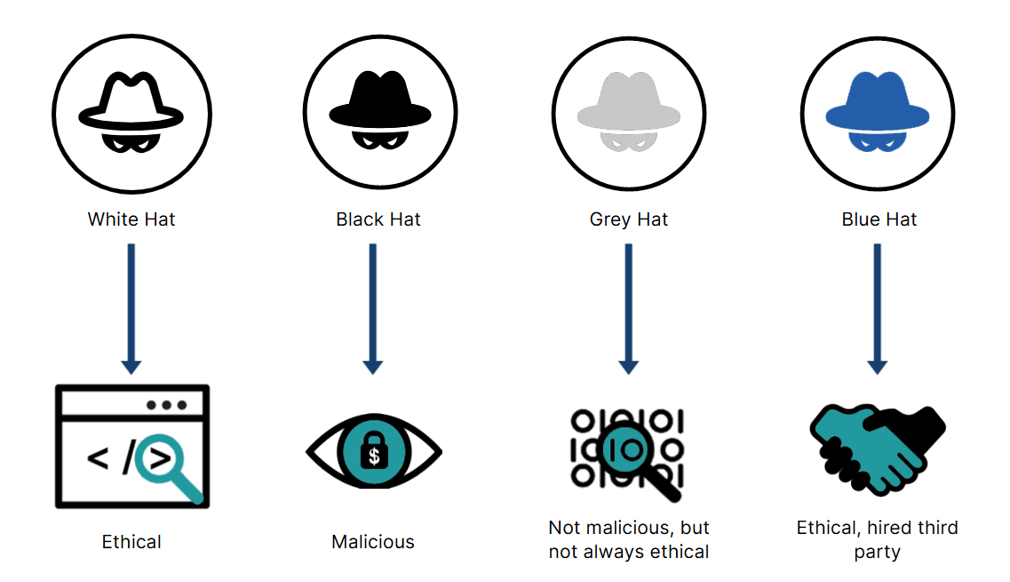

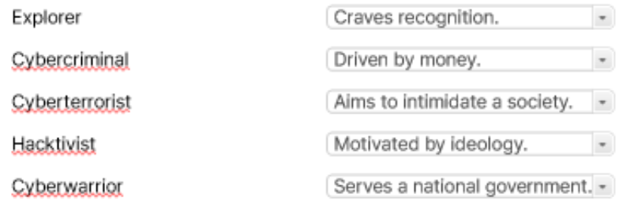

What is a cybersecurity threat?

A cybersecurity threat is an action exploiting a vulnerability that results in harm to a network or computer system. Bad actors are the instigators of cybersecurity threats. They exploit ditterent attack vectors to achieve their goals. Broadly speaking, an attack vector is a method used by a bad actor to illegally access or inhibit a network, system, or facility. You can deduce that cybersecurity threats are a subset of attack vectors. What is meant by method? Specifically, the method is how a vulnerability is exploited. There are three components that comprise an attack vector: (1) the vulnerability. (2) the mechanism or oblect that exploits the vulnerability, and (3) the pathway to the vulnerability. Here are a couple of examples. Diego receives an email from a colleague asking him to review an attached document. He saves the document to his hard drive and opens it. Unbeknownst to Diego, the sender was not really his colleague and the document installed malware onto his computer. In this example, the vulnerability is the user, the mechanism is the malware and the socially engineered message that convinced him to download the document, and the pathway is the email.
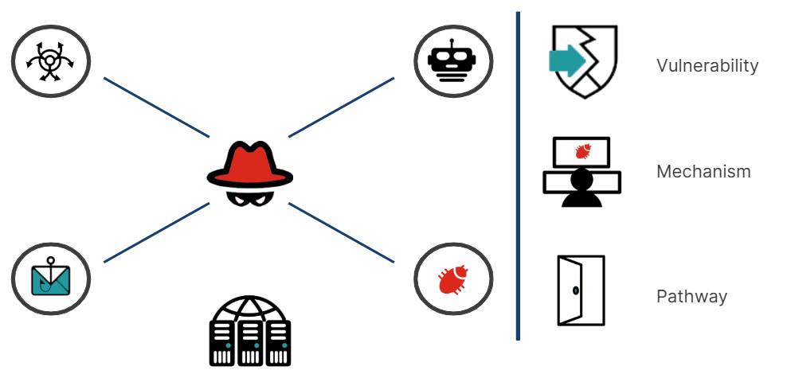
In another example, an authorized person is entering a server room, which is a restricted zone. He notices a technician laden with boxes and computer equipment loitering outside. She explains that she needs to upgrade some equipment but forgot her access pass. Although, the authorized person doesn't recognize her, she sounds convincing and he wants to be helpful, so he opens the door and she passes through. While in the server room she discretely connects a USB device to one of the servers that installs malware. In this example, the vulnerability was the authorized person and an unprotected server. The mechanism was the malware and the situation used to convince the man to allow her access to the server room. The pathway was the door into the server room and the USB device that released the malware. As you see from these two examples, attack vectors can be divided into electronic social engineering, physical social engineering, and technical, which includes vulnerabilities such as computer misconfiguration. You may have noticed in this last scenario that there were multiple attack vectors. The bad actor first needed to access the facility before she acquired access to the server room, and the server infection was merely the first stage in a chain of events that may include reconnaissance and the exfiltration of data. The preparation of an attack campaign is sometimes referred to as an attack path. An attack path is the chain of events that occurs when attack vectors are exploited.

Main Cybersecurity Threat Categories

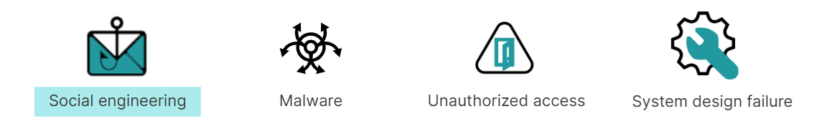
Cybersecurity threats can be divided into four categories: social engineering, malicious software (known as malware), unauthorized access to physical places or computer systems, and system design failure. Social engineering is the act of using psychological manipulation to trick people into taking some action that is contrary to their best interests, such as disclosing confidential information. The ingredients of a successful social engineering attack usually involve gaining the trust of the victim and then compelling them to act. Malware is software that is designed to disrupt, damage, or gain unauthorized access to a computer system. Unauthorized physical access could be a bad actor following an authorized person through a door after they have swiped their badge. This is known as tailgating. Unauthorized digital access could be a bad actor looking over someone's shoulder as they type their credentials. System design failure is a security flaw in a computer system or application that the bad actor exploits to gain access to a computer system. There are many examples of cyberattacks that fall into one or more of these categories.

Common Cybersecurity Attack Vectors
Attack vectors can be categorized in several ways and are often combined with other vectors to achieve the desired result. For example, a distributed denial-of- service (DDoS) attack involves a command and control (C&C) server signaling to thousands of infected computers to send requests to a targeted server at the same time. However, before a DDoS attack can be invoked, the bad actor must first infect thousands of computers. How do they do that? One common method is phishing. The bad actor can send a phishing email to millions of unsuspecting users, and some of those users will click on the link provided that will install malware on their computers. Other forms of phishing, such as whale phishing or spearphishing, may not be suitable for setting up a DDos botnet, or farm of infected computers, but they would be suitable for installing Trojan horse malware or ransomware on a specific individual's computer. Whale phishing is a phishing attack aimed at a high level target, such as a CEO or CFO of an organization. These individuals are targets because they have access privileges to servers and databases, which the bad actor wants access to. The email is carefully crafted to be plausible and personalized to ensure the target is not alerted to the scam. Within the email could be an attached document or a link. Once opened, the document appears entirely harmless, but behind the scenes malware is installed on the target's computer. This is known as a Trojan horse attack. From there, the malware can leverage the individual's network privileges to access and infect other computers. The initial targeted computer is merely the access point to the network in a multi-staged attack.
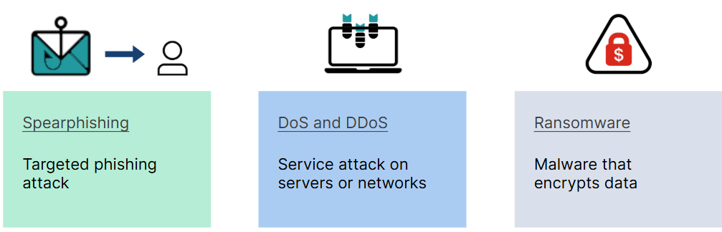
As you can see, some attack vectors, such as phishing. are uses To exploit a Weakness to gain a foothold in a computer system, while other attack vectors, such as DDos, ransomware, and Irojan horse, are used during the post-exploit stage. The exploited weakness can be human, computer technology, or a combination of the two. In the case of phishing, the weakness is human nature. It is a default trait of human nature to trust, especially if a request seemingly comes from an official source or if you know the person or thing who is making une recuest An example or explolting computer technology during the pre-exploit stage is the birthday attack. This attack exploits a weakness in some hashina algorithms, which are often used to protect passwords. Last, a brute force attack is typically a method to steal someone's credentials. It involves simply trying every possible combination until the bad actor quesses correctly, but success relies on the taraeted individual using a weak password. This type of attack is pre-exploit and relies on human fallibility. If you were a network administrator, you could neutralize this attack by implementing a strong password policy. As this suggests, there are many counteractions that you can take against the listed attack vectors. Throughout this course, you will be introduced to more attack vectors deployed by bad actors and the measures used to counter them.

